ST MARTINS GAA SUMMER CAMP 2019
12TH TO 16TH AUGUST 2019
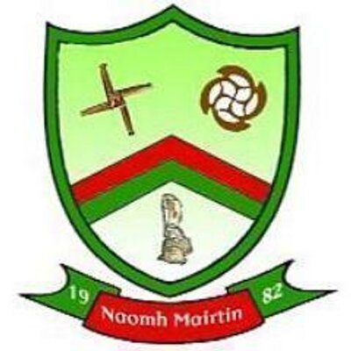
OPEN TO ALL ST MARTINS CLUB MEMBERS
PLACES LIMITED TO FIRST 120 REGISTERED WITH THIS LEAFLET
COST OF CAMP
€55 ONE CHILD
€100 TWO CHILDREN
€130 THREE CHILDREN
BOYS AND GIRLS AGED 6-13
HURLING, CAMOGIE AND GAELIC FOOTBALL
CAMP RUN BY QUALIFIED COACHES
EMPHASIS ON FUN AND PARTICIPATION
APPEARENCES BY INTER-COUNTY PLAYERS
CAMP STARTS 10AM MON-FRI
CAMP FINISHES 2.15PM MON-THURS 1PM FRI
PARTICIPANTS SHOULD BRING A PACKED LUNCH/ HELMET/ GUMSHIELD AND BOOTS
PLEASE RETURN APPLICATION FORMS ASAP TO
JOHN MULHALL
KNOCKNOO, BALLYFOYLE, CO. KILKENNY
CONTACT 0872722181
NOTE: ALL CHEQUES MADE PAYABLE TO ST MARTINS GAA

ST MARTINS GAA SUMMER CAMP 2019
CHILD ONE
NAME:
DOB:
ADDRESS:
PARENT/GUARDIAN:
SCHOOL:
EMAIL:
CONTACT NO:
MED CONDITIONS:
CHILD TWO
NAME:
DOB:
ADDRESS:
PARENT/GUARDIAN:
SCHOOL:
EMAIL:
CONTACT NO:
MED CONDITIONS:
CHILD THREE
NAME:
DOB:
ADDRESS:
PARENT/GUARDIAN:
SCHOOL:
EMAIL:
CONTACT NO:
MED CONDITIONS:

